|  |  |
| --- | --- |
| MECE Framework on Home Prices | |
|  | |
| DATE: 20 JULY 2022 | REPORT BY: **SWETA RAI** |

|  |  |  |  |
| --- | --- | --- | --- |
|  |  |  |  |
|  | PROBLEM STATEMENTWe need to analyze all the factors that could influence residential home prices across the United States over the next decade. How these factors are going to create those effects and a MECE framework output to depict the same.Housing price problem is an important economic and social issue of wide spread concern, which affects the life quality of urban as well as rural residents and also affects the continued steady growth of national economy. Based on method of multiple linear regression analysis, this report shows the relationship between housing prices and the influencing factors in the aspects of demand and supply, and identifies the main factors of influencing the housing prices in US. It tries to provide the valuable reference for any organization to regulate the housing market effectively. | |  |
|  | Introduction | |  |
|  | It looks like even post pandemic the great housing boom in the U.S. is continuing without any reduction in intensity after eight years of strong house price growth. It has been kept afloat by continued low interest rates and by the government's massive stimulus packages to cushion the impact of the pandemic. A limited supply of properties in the market has added to upward house price pressure.  The S&P CoreLogic Case-Shiller Home Price Indices seasonally-adjusted national home price index rose by an amazing 19.7% during the year to July 2021 (13.61% inflation-adjusted), a sharp acceleration from the previous year's 4.85% growth and the biggest year-on-year increase ever recorded. | This is supported by figures released by the Federal Housing Finance Agency, which showed that its seasonally-adjusted purchase-only U.S. house price index rose by 19.17% year-on-year in July 2021 (13.11% inflation-adjusted), sharply up from the prior year's 6.92% growth and also the highest annual growth on record till date.  Prices for homes have skyrocketed since the onset of the pandemic, data have them up anywhere between 32 percent and 39 percent higher. The current median sale price of houses sold in the US in the first quarter of 2022 was $428,700 according to the St Louis Federal Reserve. Most economists though agree that the pace of rising prices can’t continue and will at worst level off or rise more slowly. |  |

|  |  |  |  |
| --- | --- | --- | --- |
|  |  |  |  |
|  | WHAT IS MECE FRAMEWORK? MECE (Mutually Exclusive Collectively Exhaustive) is a systematic problem-solving framework that helps to solve complex problems. It can help you eliminate confusion and focus on key data that points the way toward success.  The MECE framework (no gaps and no overlaps) is a valuable tool for breaking down complicated problems into basic components. This way you can evaluate and estimate information to get to the root of the problem. Thinking this way is useful because it helps you avoid duplication and clarifies your options for resolving the problem. | The MECE Principle suggests that to solve any problem, you need to first understand your options by sorting them into two categories:  Mutually Exclusive (ME) – includes items that can only fit into one category at a time (in other words, there is no overlap between them).  Collectively Exhaustive (CE) – means all items can fit into one of the categories (there is an overlap between the two different areas of the framework).  There are three main benefits to MECE structures that clients love:   1. Clean and intuitive. 2. No risk to miss something. 3. No duplication of work. |  |
|  |  | |  |

|  |  |  |  |
| --- | --- | --- | --- |
|  | Factors affecting the Real Estate Market in the U.S. are:  1. Demographics (Age, Race, Gender, Income, Migration patterns):  Demographics are the data that describes the composition of a population, such as age, race, gender, income, migration patterns, and population growth. These statistics are an often overlooked but significant factor that affects how real estate is priced and what types of properties are in demand. Major shifts in the demographics of a nation can have a large impact on real estate trends for several decades.  There are numerous ways this type of demographic shift can affect the real estate market, but for an investor, some key questions to ask might be:   1. How would this affect the demand for second homes in popular vacation areas as more people start to retire? Or 2. How would this affect the demand for larger homes if incomes are smaller and the children have all moved out?   These and other questions can help investors narrow down the type and location of potentially desirable real estate investments long before the trend has started.  2. Economy (GDP, Unemployment Rate, Manufacturing Growth, Prices of goods and services [INFLATION]):  Another key factor that affects the value of real estate is the overall health of the economy. This is generally measured by economic indicators such as the GDP, employment data, manufacturing activity, the prices of goods, etc. Broadly speaking, when the economy is sluggish, so is real estate.  However, the cyclicality of the economy can have varying effects on different types of real estate. For example, if a REIT (real estate investment trust) has a larger percentage of its investments in hotels, it would typically be more affected by an economic downturn than a REIT that had invested in office buildings. Office tenants generally have longer-term leases that can't be changed in the middle of an economic downturn. Thus, although you should be aware of the part of the cycle the economy is in, you should also be cognizant of the real estate property's sensitivity to the economic cycle.  3. Interest Rates (Loans/Mortgages):  Interest rates also have a major impact on the real estate markets. If you're considering buying a home with a mortgage it is beneficial to research interest rates using a mortgage calculator. Changes in interest rates can greatly influence a person's ability to purchase a residential property. That is because the lower interest rates go, the lower the cost to obtain a mortgage to buy a home will be, which creates a higher demand for real estate, which again pushes prices up.  It's important to note that as interest rates rise, the cost to obtain a mortgage increase, thus lowering demand and prices of real estate. However, when looking at the impact of interest rates on an equity investment such as a real estate investment trust (REIT), rather than on residential real estate, the relationship can be thought of as similar to a bond's relationship with interest rates. When interest rates decline, the value of a bond goes up because its coupon rate becomes more desirable, and when interest rates increase, the value of bonds decreases. Similarly, when the interest rate decreases in the market, REITs' high yields become more attractive and their value goes up. When interest rates increase, the yield on a REIT becomes less attractive and it pushes their value down.  4. Government policies or subsidies:  Legislation is also another factor that can have a sizable impact on property demand and prices. Tax credits, deductions, and subsidies are some of the ways the government can temporarily boost demand for real estate for as long as they are in place. Being aware of current government incentives can help you determine changes in supply and demand and identify potentially false trends.  For example, due to COVID-19 breakout the housing sector saw a dip and to reduce further impacts a Housing Supply Fund financing was provided for affordable housing production to develop 500,000 units of housing for low- and moderate-income renters and homebuyers.    Quantitative Analysis of Main Influence Factors for Home Prices:  In this section, we present a quantitative analysis model based on multiple linear regression to find out the main influence factors for housing prices.    Where ‘y’ denotes the housing prices, ‘x’ and its exponential(s) denote the influence factors for housing prices such as per-capita income, quantity of urban population and bank rates so on, while ‘a0’ is a constant and the remaining ‘a’ denoted variables are the regression coefficients with ‘n’ being the regression remainder.  So, once we have collected or obtained the real time market data we can simply plug in those values to our mathematical formula and generate the relative analysis based on the given method.  Further Real Estate trends observed until July 2022:   1. House Hunting is now going digital via applications and websites allowing even virtual tours of the properties via drone videos 2. People are moving from expensive cities to the suburbs with increase in remote work availability 3. The Sun Belt’s popularity is still on a rise where property at warmer places sell faster compared to their colder counterparts 4. Single-Family housing demands are creating shortage resulting in growing buyer demand for housing construction 5. Home prices are still on a rise after the short hiccup during the beginning of pandemic where the housing market temporarily reversed course as prices dropped for a couple of months 6. Mortgage rated dropped according to some sources it had hit the 50-year low in 2020 post which a spike was seen in the applications 7. Due to people shifting from the cities to the suburbs a decline in rental property market was observed but it also created real estate investment opportunities   Taking look at some available graphs published by US real estate experts who had collected and analyzed the actual data.  We extracted a decade worth of trend in the median sale price of homes sold in the United States including the U.S. recession phase.    The below table shows us 10 years of quarterly change in housing prices with adjusted inflation factor taken into consideration.    The graphical representation shows us the trend where the red line depicts home prices with respect to currency per square and the blue line represents the actual inflation adjusted home prices in the U.S.    The percent price change observed year on year with a nominal value shown in red is then corrected with the real data drawn in blue line.    The overall GDP growth and Inflation details with respect to the economy is showing in the line graph for almost 20 years. We can see the lowest steep in GDP growth for the year 2020 when the COVID-19 pandemic broke and affected growth rates in each and every sector.  The U.S. Fed recently upgraded its 2021 economic growth forecast to 7%, from its earlier projection of a 6.5% growth in March 2020. The U.S. economy contracted by 3.5% during 2020, in contrast to an annual growth of 2.2% in 2019 and the biggest decline since the demobilization from World War II in 1946, as the country was ravaged by the global pandemic in the year 2020.  Nationwide inflation eased to 5.3% in August 2021 from a 13-year high of 5.4% in June and July, but it is still far higher than the Fed’s target of 2%. The unusually high inflation is mainly due to widespread shortages of labor and business supplies.  In August 2021, the unemployment rate dropped to 5.2%, sharply down from 8.4% a year earlier and from a peak of 14.8% in April 2020, according to the U.S. Bureau of Labor Statistics. But it remains higher than the average unemployment rate of 4.4% from 2015 to 2019. |  |  |

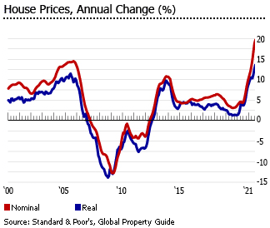The total number of existing homes available for sale fell by 13.4% y-o-y to 1.29 million units in August 2021, according to NAR. Existing homes inventory was only at 2.6 months’ supply, down from 3 months a year earlier and from 4 months’ supply two years ago.

U.S. homebuilder sentiment stood at 76 in September 2021, up slightly from 75 in the previous month, according to the National Association of Home Builders (NAHB)/Wells Fargo Housing Market Index (HMI). A reading of 50 is the midpoint between positive and negative. Sentiment stood at 83 in September 2020 and reached a record high of 90 in November. It then dropped dramatically in the following months, as lumber prices surged and supply chain disruptions hampered construction activity.

**Issue/Logic Tree (MECE):**

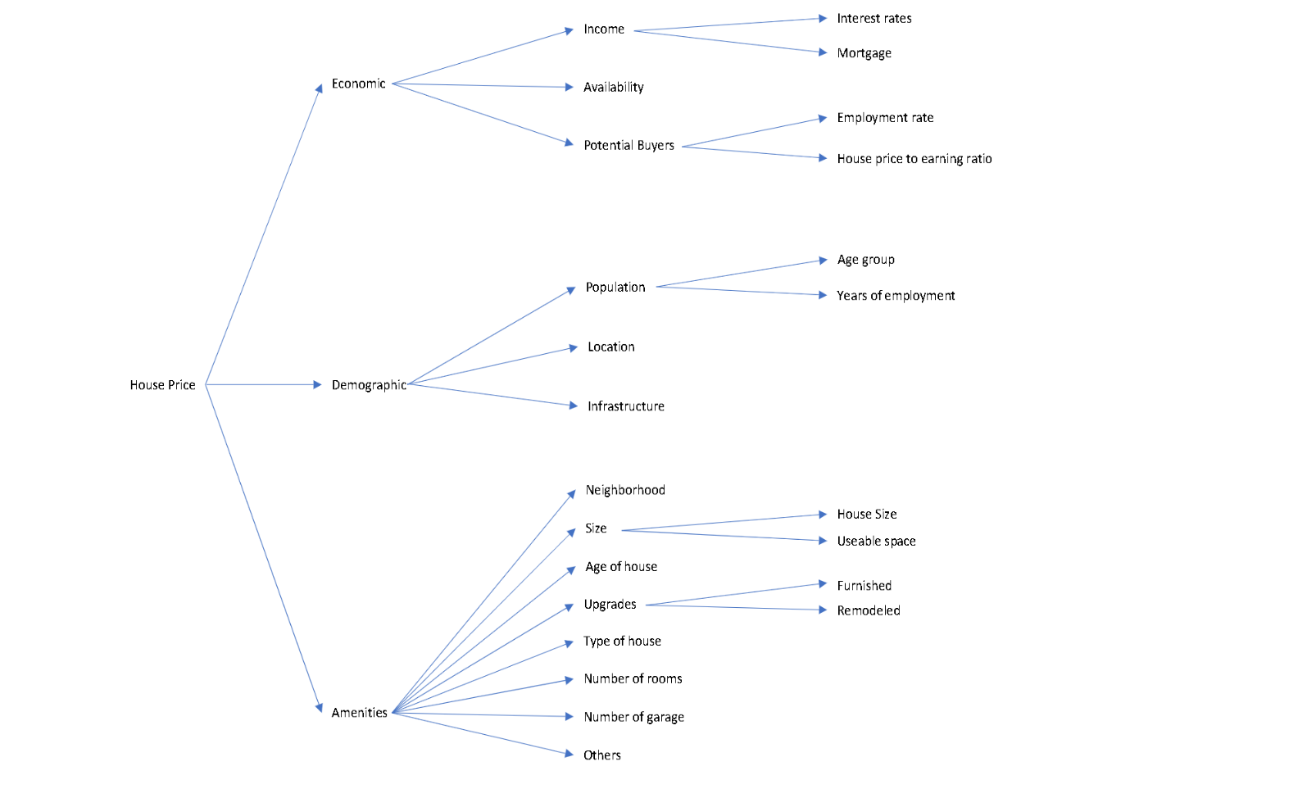

**Decision Tree (MECE):**

**Hypothesis Tree (MECE):**

Considering that we have the sample size (more than 30 for a normal distribution), sample mean value, sample standard deviation and the population mean or hypothesized mean μ with us. This will eventually allow us to formulate the p-value and help us in deciding whether reject the null hypothesis or fail to reject our original null hypothesis.

Conclusion:

This report provides a high-level overview of the economic researches related to the impact of the COVID-19 pandemic on real estate markets. Here we have majorly focused upon the residential property in the USA excluding the commercial property as well as the mortgage market. Nevertheless, the reviewed research shows that due to the heterogeneity of real estate and varying transmission channels from initial macroeconomic shocks, all real estate markets are affected in different ways by the outbreak of the corona virus. In particular, the summarized findings are valuable for various countries who are currently fighting the waves of corona infections and those who have to prepare for potential future waves. In addition, future research should consider existing studies on COVID-19 and should dig deeper on possible links between real estate markets, the macroeconomy and financial markets.

Let me conclude. Housing booms have different characteristics across countries and time periods. What is common is that when the bust comes, it very often damages financial stability and the real economy. The tools for containing housing booms are still being developed. The evidence on their effectiveness is only just starting to accumulate. The interactions of various policy tools can be complex. But all this should not be an excuse for inaction. The interlocking use of multiple tools might overcome the shortcomings of any single policy tool. We need to move from “benign neglect” to an “all of the above” approach when it comes to policy choices.

All housing markets are local, and county-level data do not capture all of the nuances that could drive the price of a given home in a given neighborhood. On the whole, the U.S. housing market still looks considerably less risky than it did in the mid-2000s. While there are some pockets of rapid price growth and extremely high price levels, in addition to a few places with fairly high prices despite growing supply, there is nowhere that has combined these price patterns with rapid debt growth, as occurred in some places in the mid-2000s.

